Order Of Lenten Service

Opening Hymn: TLH 143 vs 1-5

Reading: Lent III

The History of the Passion of our Lord

Sermon Hymn: TLH 421

Sermon Text: Hebrews 13:11-12

Jesus Outside The Camp

Prayer

Holy Communion

The Lord's Prayer

The Blessing

Closing Hymn: TLH 156

* * * * * * * * * * * * *

Koinonia Hour

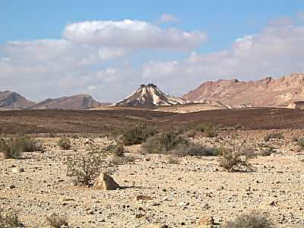

Barren Wilderness

Water
Of
Life
1 March 2015

W A T E R O F L I F E

Independent Christian Church—Conservative Lutheran Doctrine

Worship Service: 9:30 a.m. Bible Study: 10:45 a.m.

Larry Cooper, Pastor E-Mail address:
111 N. Ridge Road lcooper@wateroflife.cc
Coon Valley, WI 54623 Web Site:
Phone: (608) 452-2105 www.wateroflife.cc

* * * * * * * * * * * * * * * * * * * * * * * * * * *

Sermon Text: Hebrews 13:11-12

Jesus—Outside the Camp

* * * * * * * * * * * * * * * * * * * * * * * * * * *

11: For the bodies of those beasts, whose blood is brought into the sanctuary by the high priest for sin, are burned without the camp.
12: Wherefore Jesus also, that he might sanctify the people with his own blood, suffered without the gate.

A little background:

As another has said: “The reference here is to the sin offerings. These were slain on the altar in the outer court, but their blood was carried inside the tabernacle and sprinkled before or upon the throne of Jehovah, while their carcasses were utterly consumed outside the camp. This was while Israel were sojourners in the wilderness and lived in tents but the same order was observed after they entered Canaan and the temple was built in Jerusalem—the bodies of the sin offerings being carried out beyond the walls of the city to be consumed there.”

Some Old Testament References:

Leviticus 4:1-12—when a priest had unwittingly sinned. See especially verse 12—“ Even the whole bullock shall he carry forth without the camp unto a clean place, where the ashes are poured out, and burn him on the wood with fire: where the ashes are poured out shall he be burnt.”

Leviticus 4:13-21—when the whole congregation sinned through ignorance. See especially verse 21—“ And he shall carry forth the bullock without the camp, and burn him as he burned the first bullock: it is a sin offering for the congregation.”

But there is no doubt that the apostle here in Hebrews 13:11-12 was alluding mainly to the chief sin offering which was offered on the annual day of atonement described at length in Leviticus 16.

We will look in more detail at this chapter this morning. But here especially notice verse 14—“ And he shall take of the blood of the bullock, and sprinkle it with his finger upon the mercy seat eastward; and before the mercy seat shall he sprinkle of the blood with his finger seven times.” And then verse 27—“ And the bullock for the sin offering, and the goat for the sin offering, whose blood was brought in to make atonement in the holy place, shall one carry forth without the camp; and they shall burn in the fire their skins, and their flesh, and their dung.”

